SETUP EPIN

1. Setup Acquiring Contracts & Devices
2. Navigate ROOT > OpenWay > Full > Acquiring > Acquiring Contracts > Client (Corporate)
3. Select “OCB - TTT”
   * Click “Acq Contr” tab
     + Click “Insert new record” to add a new acquiring contract
     + Input values
       - Contract Name: OCB - TTT - EPIN
       - Date Open: Current Date
       - Contract SubType: Merchant Client Account Contract
       - Status: Account Normal
       - Service Pack: Acq Commercial Account Svc
       - Account Scheme: POS Acc Scheme Standard
       - Comment Text: OCB - TTT POS - EPIN
       - Report Type: Merchant Default
       - Product: POS Merchant
       - Merchant Id: 000000000000001
       - Branch: ORIENT COMMERCIAL BANK
     + Click “Save form changes”
   * Click “Address” tab 🡪 Show “Address for OCB - TTT - EPIN” form
     + Click “Insert new record” to add a new address
     + Input values
       - Type: Address for Payment Scheme
       - Country: Vietnam
       - ZIP: 700000
       - City: HCM
       - Merchant Name: OCB EPIN
       - Location: HCM
       - Is Active: Yes
     + Click “Save form changes”
     + Close form
   * Click “Devices” 🡪 Show “Device for OCB - TTT - EPIN” form
     + Click “Insert new record” to add a new device
     + Input values
       - Terminal ID: OCB_EPIN
       - Client: OCB - TTT
       - Device Name: OCB - TTT - EPIN
       - Product: POS Retail VND
       - Type: OCB POS Device Contr
       - Service: OCB POS Retail VND Dev Svr
       - SIC Code: 4900
       - Status: Device OK
     + Click “Save form changes”
     + Click “POS” tab 🡪 Show “POS for OCB - TTT - EPIN” form
       - Input values
         * POS Type: OCB BANK HYPERCOM
       - Click “Save form changes”
       - Close form
     + Close form
   * Click “Action” > “Approve”
4. Setup Service Pack
   1. Add Preference

* Navigate ROOT\OpenWay\Full\Configuration Setup\Products\Product Definition\Preference Types
* Click “Insert new record”
* Input values
  + Name: Change EPIN Conditions
  + Code: CHANGE_EPIN_CONDITIONS
  + Contract Cat: Card
* Click “Save form changes”
  1. Add Service Pack
* Navigate ROOT\OpenWay\Full\Configuration Setup\Products\Service Packs
* Select “001-Add LC Debit Usage” & Click “Preferred” 🡪 Open “Preferred for …” form
  + Click “Insert new record”
  + Input values
    - Preference Type: Change EPIN Conditions
    - Is Active: Yes
  + Click “Save form changes”
  + Click “Full Info” 🡪 Open “Full Info for …” form
    - Update values
      * Doc Tag Name: AUTH_AGENT
      * Doc Tag Value: API
      * Custom Parms: DOC_TAG=PINM;DOC_TAG_VALUE=REQUEST;
    - Click “Save form changes”
* Select “001-Add LC Debit Usage” & Click “Usage” 🡪 Open “Usage for …” form
  + Click “Insert new record”
  + Input values
    - Usage Code: CHANGE_EPIN_LIMIT
    - Usage Type: Add Service
    - Channel: Our POS
    - Period: 1
    - Period Type: Day
    - Usage Event: Usage
    - Max #: 5
    - Is Active: Yes
  + Click “Save form changes”
  + Click “Details” 🡪 Open “Details for …” form

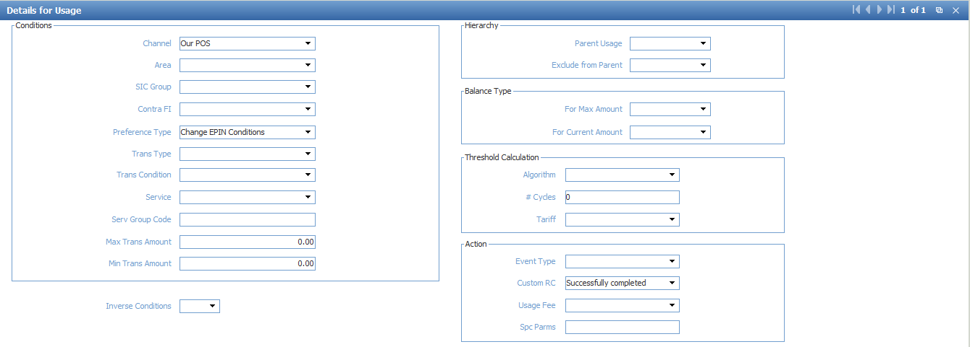

* Approve service pack and related service pack
* Do the same for “001-Add MC Debit Usage”, “001-Add JCB Debit Usage” “001-Add MC Credit Usage”, “001-Add JCB Credit Usage”, “001-Add LC Credit Usage”, “001-Add MC Prepaid Usage”, “001-Add LC Prepaid Usage”, “001-Add MC Debit Coporate Usage”

1. Setup Production Event

* Navigate ROOT\OpenWay\Full\Configuration Setup\Transaction Types\Production Events
* Add “PIN_SET=Y;” into “Add Prod Parms” for all records

1. Setup Card Contract Type

* Navigate ROOT\OpenWay\Full\Configuration Setup\Contract Types\Card Contract Types
* Select “OCB MasterCard Cards” & Click “SubTypes” 🡪 Open “SubTypes for …” form
  + Add “PIN_SET=Y;EN_SRVC_WHEN_LOCKED;” into “Add Parms” for all records
* Do the same for “OCB Local Cards”, “OCB JCB Cards”